Characteristics of Adult Learners #1

Adult learners have ...

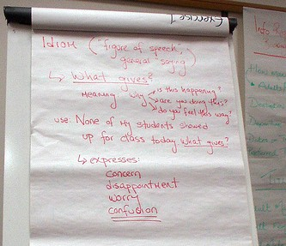
Specific purposes for coming to class

In general, adult learners have a specific reason for taking a class. Sometimes adults begin attending classes after a life-changing event, such as a marriage, divorce, a new job, or sudden unemployment. Others may desire to learn specific information or knowledge. Regardless of the reason they joined the class, adults have specific results in mind for education and expect those results quickly. Some adults have dropped out of educational settings before and will do so again if they are dissatisfied or if something else temporarily takes priority in their lives.

Listen to an ESL student talk about why she is taking an adult education class.

Summary of Audio:
She is coming to school to learn English, more grammar, writing, improve living, being able to help her son who is in school with his English homework. She won’t come to class anymore if the teacher doesn’t give her enough English grammar. She feels that if she isn’t given enough grammar, it is a waste of time to be in class.

Characteristics of Adult Learners #2

Adult learners have ...

Numerous obligations

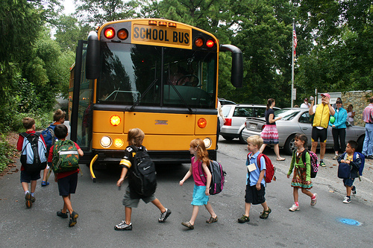

Adults are busy people with many obligations in their lives. Adult learners often have to juggle their jobs, their households, taking care of children, and sometimes taking care of their parents. Consequently, adult learners may have erratic attendance. Often, a change in the work schedule, an opportunity for overtime, or a sick child will mean the adult learner will miss class.

Likewise, some adult learners may have little or no time to study or work on homework or other out-of-class assignments due to their many other obligations.

Listen to an adult education student talk about the many obligations she has in her life.

Summary of Audio:
The woman says that the students have many responsibilities and jobs to do so they don’t have time to do homework. Some things they do is cook, clean, and help with kids as well as go to work. Sometimes the students come early because have to drop kids off at school. Sometimes students can’t go to class or they have to leave early because of work/home responsibilities. She says, in summary, that many students can’t do homework because they are very busy.

Characteristics of Adult Learners #3

Adult learners have ...

Rich life experiences

Adult learners have a broad experience base upon which to relate new learning. Oftentimes, adult learners are experts in areas that the classroom teacher knows nothing about. It is useful for the adult education teacher to find ways to incorporate adult learners' past experiences, knowledge and skills when planning lessons. Occasionally, adult learners may question new information that contradicts their previous beliefs or experiences.

Listen to a student talk about the importance of sharing experiences.

Summary of Audio:
The man feels “good inside” and like a teacher when he shares the things that he has learned about (as he was growing up) and hears about what other people know and what they have learned in life.

Characteristics of Adult Learners #4

Adult learners have ...

Diverse abilities

Adult learners bring to the classroom differences in skill level and ability. For example, a student could have good English listening skills but poor reading skills. Another could have strong reading skills but poor math skills. Regardless of how the class has been leveled for enrollment, there is bound to be a variety of skill strengths and weaknesses in any class group.

Listen to a math teacher talk about the different skills and abilities her students have.

Summary of Audio:
The lady speaking is an Associate math professor at a college and has taught many students from diverse backgrounds. Students receive placement assessments, she adds, but the assessments do not fully encompass all of their knowledge of English. So her classes end up being at multi-level, made up of students who learn differently. Some students want to learn from each other and some want to learn from the teacher (in lecture format or one-on-one). She says that some students can compute math, but some find it difficult to apply it to a real life situation. Other students have learned something one way (such as writing) from their country and find it very hard to accept that are way of doing something is not wrong.

Characteristics of Adult Learners #5

Adult learners have ...

Physical considerations

Adult learners, especially those who are older, may have some physical limitations that must be taken into account such as trouble sitting for long periods of time. Adults may have difficulty hearing the teacher or their classmates. Adults may also have trouble seeing the board or smaller fonts on a handout.

Listen to an adult education student talk about how his vision problems affected his education.

Summary of Audio:
A man speaks of his experience of getting made fun of at school because of his glasses, so he stopped wearing them. When he was in school, he had lots of difficulties learning because he wanted to seem cool. When he went to his GED class, a teacher noticed that he was squinting and got him glasses. He is very glad he got glasses and remarks of how clear and how much more easily he can do his work since he can see clearly now.

Characteristics of Adult Learners #6

Adult learners have an ...

Established sense of self

Adults have established a sense of self prior to enrolling in class. Previous bad experiences in school or frustrations over an inability to express themselves well in English can affect adult learners’ self-esteem and confidence. Regardless of whether their self-identity is strong or weak, positive or negative, adults want to be defined by their abilities, not their deficiencies. Adults appreciate opportunities for learning that support self-esteem instead of focusing attention on perceived limitations.

Listen to an adult education student talk about how his problems with math affected his self-confidence.

Summary of Audio:
A man speaks of how he began adult education classes because he didn’t feel like he learned what he wanted to learn in high school. He tells of how the teacher showed respect for each student as an individual and can point out each student’s weaknesses-- not in a way in which is to discourage them or put them down, but to show them where they can learn and what they can work on.

Characteristics of Adult Learners #7

Adult learners have ...

Changing lives
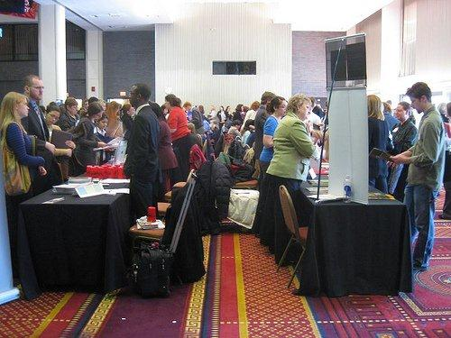

While adult learners are enrolled in class, some are in the process of undergoing major changes in their lives due to immigration, loss or gain of employment, health issues, or family situations. Sometimes returning to school affects the dynamic of relationships adult learners have at home, at work, or in the community. Improved academic or employability skills may lead to future changes as they transition into higher education, specialized training, or new occupations. All of these changes could impact classroom performance or services needed outside the class.

Listen to an adult student talk about how her life has recently changed necessitating the need for her to take adult education classes.

Summary of Audio:
A middle-aged woman who has just been unemployed for over a year in a career that she has been in for 26 years and all of the companies in that field of work have gone under. She doesn’t know how to do anything besides what she has been doing. She didn’t need to get her GED at the time when she started in the industry. She has decided to change her career in order to get something that doesn’t require as much physical labor. She is going back to school to get her GED to get a better job the second half of her life—to find something that she enjoys rather than something she feels forced to do.

I. Answer in 2.1 Forum:

What have your own experiences been with being an adult learner? How will your experiences and the characteristics you have just learned affect your classroom teaching?

2. Answer in Forum 2.2: Read the directions and then you will be asked to post your reply. (Click " Reply " at the bottom right hand side of the screen to do this.)

Directions:

Think about ways to minimize the barriers to success. You may discuss one of your own students or comment about one of the Student Scenarios below. You will need to address the following:
- State the student's needs
- List resources available
- List possible accommodations
- List other steps necessary to implement strategies to reduce barriers
Note: When you hit "Reply" at the bottom right side of the screen, the next screen will have a subject line that you will need to change. If you are talking about your own student, please use a fictitious first name only as the subject line. If you are responding about one of the students in the scenarios below, then please change the subject line to that name. To view all of the forum posts after you have submitted your ideas, click on Continue.

Student Scenarios:

Armando Baca Armando is 32 and married with four children. He speaks English fairly well, although he sometimes has trouble understanding his co-workers and his supervisor at the plant nursery where he works because they speak so fast. He is a hard worker and frequently works long hours to support his family. His wife is pregnant with their fifth child. Armando graduated from the 8th grade in Mexico before coming to this country with his family to work. He attended high school here, but the family moved a lot, and he did not finish his sophomore year. He has worked in the United States since arriving here at 14. He is not a U.S. citizen. His wife, also from Mexico and also not a citizen, stays home with the children; so his earnings are the only income for the family. Armando wants to enroll in class to get his GED®.

Alice Jones Alice Jones is 22. She is single, no children, no work history. She dropped out of school in her freshman year because, as she says, “I was doin’ the drug scene and they just teach you stupid stuff in school, anyway. I’m only here ‘cuz they told me if I didn’t come here, I’d have to go to jail.” Alice has recently been arrested for shoplifting (not her first offense), and her probation officer strongly suggested that she “get her GED and make something of herself.” Adult education classes in Alice’s community meet four days per week, 3 hours per day, for 12 weeks. Alice’s TABE Reading is 5.5; Math is 4.2.

David Frazier David is originally from Harlan County, Kentucky, where he worked for 19 years as a coal miner. He is 42, divorced with two grown children. When his mine in Kentucky shut down, he moved to Southern Illinois, hoping to get a job in one of the few coal mines still in operation there. He soon learned that he had to have a high school diploma or GED before he could even be considered for employment. David is bitter about not being able to find work in the field he knows so well and in which he has so many years of experience, simply because he did not graduate from high school. David’s TABE score is 7.4 in Reading.

Olga Karznikova Parker Olga is 27, from Russia. She is not currently working, although she wants to get a job, preferably doing something with computers. She worked with computers in Russia, as a graphic designer. She is married to an American Marine, who is currently serving in Iraq. Olga has a high school diploma in Russia. She speaks English but, in her words, “I read better than I speak.” She often becomes frustrated with herself, because she does not always understand her Illinois friends and neighbors when they use slang terms or idiom. Olga would like to improve her English speaking skills, but she desperately wants to get her driver’s license so that she doesn’t have to depend on neighbors or friends to take her places and so that she can go alone to job interviews.

